Final
DAMAGE ASSESSMENT AND RESTORATION
PLAN/ENVIRONMENTAL
ASSESSMENT FOR THE
June 8, 2000
T/V POSAVINA OIL SPILL

Prepared by:

National Oceanic and Atmospheric Administration
U.S. Department of the Interior (US Fish and Wildlife Service)
Massachusetts Executive Office of Environmental Affairs

January 2004

EXECUTIVE SUMMARY

The T/V Posavina oil spill occurred on June 8, 2000 in East Boston, Massachusetts at the Tosco Marine Terminal located in the Chelsea River portion of Boston Harbor. The spill released 59,600 gallons of oil (IFO 380). Calm weather conditions, slow moving tidal currents, and a quick response time resulted in an approximately 89% recovery. Shoreline oiling occurred throughout the Chelsea River, coating areas of rip-rap walls, deteriorated bulkheads, and several relatively small areas of Spartina sp. salt marsh vegetation scattered along the shore. Field surveys and observations made during preassessment activities indicated that approximately five acres of shoreline were oiled, a third of which were estimated to be wetlands and the remainder was man-made structures and highly disturbed.

This Final Damage Assessment and Restoration Plan/Environmental Assessment ( Final DARP/EA) has been prepared by state and federal natural resource Trustees¹ for the restoration of natural resources and public use services that were exposed and/or injured by the T/V Posavina oil spill. This Final DARP/EA is issued to inform the public concerning the Trustees’ authorities and responsibilities under the Oil Pollution Act (OPA) (33 § 2701, et seq.) and the National Environmental Policy Act (NEPA), as amended, 42 U.S.C. § 4321 et seq.

The Trustees evaluated a range of restoration alternatives which would provide additional resource services to compensate the public for losses pending natural recovery of resources exposed/ or injured by the T/V Posavina oil spill. Potential restoration projects included wetland restoration, bank stabilization, fill removal and enhancement, and debris removal. Two salt marsh restoration projects were selected as the preferred alternatives to compensate for injured natural resources and lost services. The Mill Creek in Chelsea and the Belle Isle Fish Company project in East Boston will result in a total of approximately 2.5 acres of restored salt marsh. The impacts associated with these project are expected not to be significant.

The Final DARP/EA briefly summarizes the natural resources found in the Chelsea River (section 2.0), provides a brief description of the nature and extent of the natural resources exposed and/or injured and the lost public uses resulting from the T/V Posavina oil spill (section 3.0), and provides a discussion of restoration options to enhance recovery of the resources affected by the spill (section 4.0).

________________________________________________________________________
¹ Massachusetts Executive Office of Environmental Affairs (“EOEA”); U.S. Department of Commerce/ National Oceanic and Atmospheric Administration (“NOAA”); and the U.S. Department of the Interior (“DOI”)/ U.S. Fish and Wildlife Service (“USFWS”)

TABLE OF CONTENTS

1.0 INTRODUCTION…………………………………………………………Page

  - Purpose and Need for Restoration……………………..……..……....5
  - The T/V Posavina Oil Spill: Summary of Incident………….….……6
  - Authority and Legal Requirements……………………………..…….6
    - Overview of OPA Requirements…………………….….……6
    - NEPA Compliance……………………………….…….…….9
    - Coordination with Responsible Party…………….…….…….9
    - Public Participation………………………………………….10
    - Administrative Record………………………………………10
  - Trustees Preferred Restoration Alternatives…………….…….. …..11

2.0 AFFECTED ENVIRONMENT

  - Physical and Biological Environment..……………………….…….11
2.1.1 Endangered and Threatened Species………………………………..12
    - Essential Fish Habitat……………………………………………….13
    - Historic and Cultural Resources…………………………………….13
    - Human Use Services………………………………………………...13

3.0 NATURAL RESOURCES AND PUBLIC USE IMPACTS

  - Introduction…………………………………………………………14
  - Impact Surveys……………….……………………………………. 14
3.2.1 Shoreline Oiling Surveys………….………………………….14
3.2.2 Oiled Wildlife Surveys………….………….……….………..15
- 3.2.3 Marine Resource Surveys…………….…………….………..15
- 3.2.4 Recreational Lost Use………………………………….…….15
  - Injury Assessment, Methods and Results……….…………………..15
  - Injury Quantification………………………………...……………...16

4.0 RESTORATION ALTERNATIVES
  - Restoration Strategy……………………………………………..…..17
  - Evaluation Criteria…..…………………………………………...….18
  - Evaluation of Restoration Alternative 1: No-Action…………..……19
  - Evaluation of Restoration Alternative 2 (preferred0………………...20
    - Mill Creek Salt Marsh Restoration………….……………... 20
  - Evaluation of Restoration Alternative 3 (preferred)………………. .24
    - Belle Isle Fish Company Salt Marsh Restoration…….….….24
  - Non-Preferred Alternatives Discussion……………………….…….27
    - Condor Street..……………………………………….……...28
    - Parkway Plaza……………………..……………….….……28
    - Forbes Street Industrial Park………………….………….28
  - Essential Fish Habitat Consultation……………………….……..…30
  - Threatened and Endangered Species Act Consultation……….……30
  - Cumulative Affects of Preferred Alternatives……………………...30
  - Summary of Preferred Restoration and Costs…….…………….….30

5.0 PREPARERS, AGENCIES, AND PERSONS CONSULTED
5.1 Agencies and Persons Consulted...……………..………………..31

6.0 COMPLIANCE TABLE
  - Compliance with Environmental Federal Statues and
Executive Orders……………..………………………….………32

7.0 REFERENCESS…………………………………………….………...36

- ADMINISTRATIVE RECORD………..…………………….………36

Appendix A: Finding of No Significant Impact…………….……….……….37
Appendix B: Coordination Letters…………………………………………...40

FINAL DAMAGE ASSESSMENT AND RESTORTION PLAN/ ENVIRONMENTAL ASSESSMENT FOR THE JUNE 8, 2000 T/V POSAVINA OIL SPILL

1.0 INTRODUCTION

  - Purpose and Need for Restoration

This Final DARP/EA is intended to inform members of the public concerning the Trustees’ OPA determination of the natural resource injuries caused by the T/V Posavina oil spill and proposed restoration projects to compensate for those injuries. This Final DARP/EA also serves as an Environmental Assessment under NEPA and addresses the potential impact of the preferred restoration actions on the quality of the physical, biological, and cultural environment. As described in detail below, this plan includes two salt marsh wetland restoration projects, one in the Mill Creek in Chelsea, Massachusetts and the other located in the Belle Isle Inlet in East Boston, Massachusetts.

The purpose of restoration, as outlined in this Final DARP/EA, is to make the public whole for injuries to natural resources and natural resource services resulting from the T/V Posavina oil spill by returning the injured natural resources and natural resource services to their “baseline” condition (i.e., the condition that would have occurred but for the spill) and compensating for associated interim losses.

The regulations for conducting a sound natural resource damage assessment to achieve restoration are found at 15 C.F.R. Part 990. These regulations were promulgated pursuant to the Oil Pollution Act of 1990 (OPA) to determine the nature and extent of natural resource injuries, select appropriate restoration projects, and implement or oversee restoration. This Final DARP/EA presents information about the affected environment (sec. 2.0), the Trustees’ estimates of exposure and/or injury and service losses to natural resources caused by the T/V Posavina spill (sec 3.0) and the Trustees’ preferred restoration alternatives (sec. 4.0). Implementation of the preferred restoration projects will be conducted in accordance with a proposed settlement that the Trustees have entered into with Sociedad Naviera Ultragas, Ltd.,, the Responsible Party under OPA for the T/V Posavina oil spill.

  - The T/V Posavina Oil Spill: Summary of the Incident

The oil spill occurred at approximately 0830 on June 8, 2000 when the tugboat, Alex C accidentally collided with the T/V Posavina while assisting its departure from the dock. The collision punctured a hole in the T/V Posavina’s hull resulting in the discharge of 59,600 gallons of oil (IFO 380). The spill occurred in East Boston, Massachusetts at the Tosco Marine Terminal located in the Chelsea River part of Boston Harbor (Figure 1). The majority of the oil was confined to Chelsea Creek and associated shorelines. Some sheening was observed in Boston Harbor, but it is not clear if this was due to this incident or another source.

On-scene oil recovery equipment included vacuum trucks, small boats, skimmers and fractionalization tanks, and more than 10,000 feet of containment boom. Approximately 100 personnel were on-scene from federal, state, and local agencies and contractors. The United States Coast Guard (USCG) reported that approximately 89% of the spilled oil was recovered. The high recovery rate was attributed to calm weather conditions, slow moving tidal currents, and a quick and effective response. Forty 20-yard containers of oiled shoreline debris were also removed (SCAT Report, July 12, 2000).

The Chelsea River is located within a highly industrialized area. Oil refineries, oil transporters, fuel storage facilities, warehouses, heavy equipment facilities, rental car facilities, and railroad tracks bound the waterway. The shoreline is predominantly comprised of rip-rap walls, deteriorated wooden bulkheads, and sheet metal pilings and bulkheads. However, there are several relatively small areas of marsh (Spartina sp.) vegetation scattered throughout the Chelsea Creek shoreline.

  - Authority and Legal Requirements

This Final DARP/EA has been prepared jointly by the Massachusetts Executive Office of Environmental Affairs (EOEA), U.S. Department of Commerce / National Oceanic and Atmospheric Administration (NOAA), and the U.S. Department of the Interior (DOI) (represented by the U.S. Fish and Wildlife Service (USFWS) (collectively, “the Trustees”). Each of these agencies is a designated natural resource Trustee under Section 1006 (b) of OPA, 42 U.S.C. § 2706(b), and the National Contingency Plan, 40 CFR Section 300.600, for natural resources injured by the T/V Posavina oil spill. The Massachusetts Governor designated EOEA as the state trustee for oil spills. The state EOEA is also acting on the oil spill under the authority of the Massachusetts Oil and Hazardous Material Release Prevention and Response Act (MGL Chapter 21E). As a designated Trustee, each agency is authorized to act on behalf of the public to assess and recover natural resource damages, and to plan and implement actions to restore natural resources and resource services injured or lost as the result of a discharge of oil.
    - Overview of Legal Requirements
A natural resource damage assessment conducted pursuant to OPA and the regulations promulgated thereunder at 15 C.F.R. Part 990, consists of three phases: 1) Preassessment; 2) Restoration Planning; and 3) Restoration Implementation. OPA authorizes state and federal natural resource trustees to initiate a damage assessment, among other requirements, when natural resources may have been injured and/or natural resource services impaired as a result of the incident.
OPA regulations provide specific definitions for the following terms:

Figure 1
Locus Map of Showing Location of T/V Posavina Oil Spill

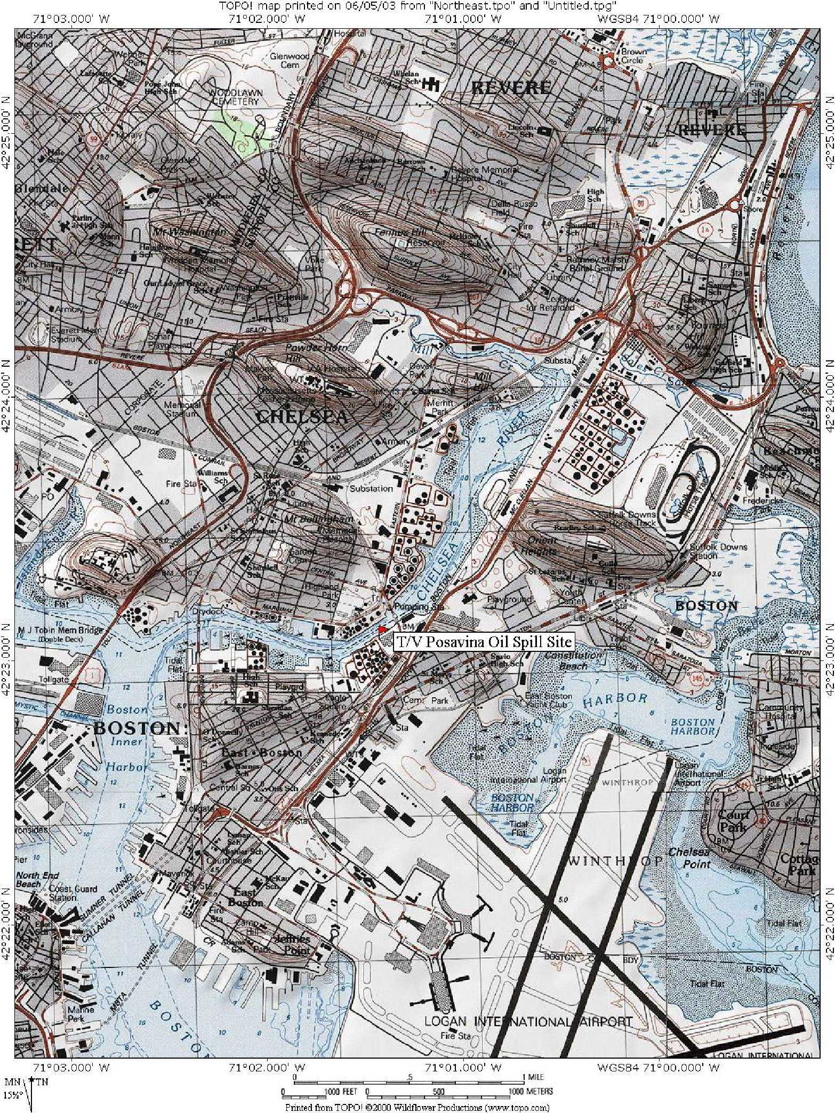

- "Injury" is "an observable or measurable adverse change in a natural resource or impairment of a natural resource service";
- "Natural resources" are "land, fish, wildlife, biota, air, ground water, drinking water supplies, and other such resources belonging to, managed by, held in trust by, appertaining to, or otherwise controlled by the United States, any state or local government or Indian tribe"; and
- "Natural resource services" are "functions performed by a natural resource for the benefit of another resource and/or the public".
During the Preassessment Phase, the Trustees determined that the provisions and determinations of OPA applied to this spill including: (1) an incident has occurred; (2) the incident is not from a public vessel; (3) the incident is not from a onshore facility subject to the Trans-Alaska Authority Act; (4) the incident is not permitted under federal, state, or local law; and (5) public trust natural resources and/or services may have been injured as a result of the incident. On the basis of those determinations, the Trustees began the Restoration Planning Phase. In this phase, the Trustees evaluated and quantified the nature and extent of injuries to natural resources and services, and determined the need for, type of, and scale of appropriate restoration actions. Using the information developed during the Restoration Planning Phase, the Trustees developed this Final DARP/EA.
The first component of the Restoration Planning Phase was injury assessment. The Trustees evaluated injury to: (1) marine communities; (2) wetlands and birds; and (3) public uses. As provided at 15 C.F.R. § 990.14(c)(1), the Trustees invited the Responsible Party to participate in the injury assessment component of the natural resource damage assessment(sec. 1.3.3). The Responsible Party was involved in the design, performance, and funding of evaluations and conclusions reached through the cooperative assessment. The assessment produced relevant information that the Trustees considered in determining the nature and extent of injuries to natural resources
The second component of the Restoration Planning Phase was restoration selection. Considering the nature and extent of exposure and/or injuries to natural resources caused by the T/V Posavina oil spill, the Trustees developed a plan for restoring the injured resources and services, which is set forth in this Draft RP/EA. In it, the Trustees identify a reasonable range of restoration alternatives, evaluate those alternatives, and using the criteria at 15 C.F.R. § 990.54, select the preferred alternatives from among them.
In selecting their preferred restoration alternatives, the Trustees considered all of the criteria outlined in the regulations, including the cost of carrying out each alternative. The Trustees are proposing selection of the least expensive practicable alternatives that are expected to provide the restoration benefits required by these criteria. In addition, the Trustees also considered whether the cost of a preferred alternative was commensurate with the value of the exposed and/or injured resource and service. The OPA Damage Assessment Regulations do not expressly require the Trustees to make this determination.
Consistent with the OPA regulations (15 C.F.R. § 990.54(a)(5)), the Trustees also considered the extent to which restoration alternatives provide benefits to more than one natural resource and/or service. As described in more detail in section 4.0 of this Final DARP/EA, the preferred restoration alternatives selected by the Trustees benefit multiple resources and/or resource services.
Natural resource trustees may settle claims for natural resource damages under OPA at any time during the damage assessment process, provided that the settlement is: 1) adequate in the judgment of the trustees to satisfy the goals of OPA; and 2) fair, reasonable, and in the public interest, with particular consideration of the adequacy of the settlement to restore, replace, rehabilitate, or acquire the equivalent of the injured natural resources and services. Sums recovered in settlement of such claims, other than reimbursement of Trustee costs, may only be expended in accordance with a restoration plan.
1.3.2 NEPA Compliance
Any restoration of natural resources under OPA must comply with the National Environmental Policy Act (NEPA), as amended (42USC 4321 et seq.), and its implementing regulations (40 C.F.R. § 1500-1508). In compliance with NEPA and its regulations, this Final DARP/EA summarizes the current environmental setting, describes the purpose and need for action, identifies alternative actions, assesses their applicability and environmental consequences, and summarizes opportunities for public participation in the decision-making process. Project-specific NEPA documents may need to be prepared under the separate regulatory processes for any selected projects (e.g., Clean Water Act §404 process)
    - Coordination with Responsible Party
The OPA regulations require the Trustees to invite the Responsible Party to participate in the damage assessment process. Accordingly, the Trustees worked with the Responsible Party to participate in the damage assessment process. A cooperative approach with the Responsible Party was undertaken that included the design, performance and funding of evaluations completed as part of this assessment. Coordination between the Trustees and the Responsible Party helped reduce duplication of studies, increase cost effectiveness of the assessment process, and increase sharing of information and experts. Input from the Responsible Party was sought and considered throughout the damage and restoration planning process. As required by the regulations at 15 C.F.R. § 990.14 (c) (4), the Trustees retain final authority to make determinations regarding injury and restoration.

    - Public Participation
Public review of the Draft DARP/EA was an integral component of the restoration planning process. Through the public review process, the Trustees sought public comment on the analyses used to define and quantify natural resource injuries and the methods proposed to restore injured natural resources or replace lost resource services. The Draft RP/EA provided the public with information about the nature and extent of the natural resource injuries and identify and evaluate restoration alternatives.
No substantive public comments were received during the pubic comment period for the Draft DARP/EA. What limited comments were received were evaluated by the Trustees prior to selection of the final projects and issuance of a Finding of No Significant Impact (FONSI).
Public review of the Draft DARP/EA was consistent with all state and federal laws and regulations that apply to the natural resource damage assessment process, including Section 1006 of OPA regulations, 42 U.S.C.§2706; the OPA (15 CFR Part 990); NEPA, as amended (42 USC §4371, et seq.); and its regulations (40 CFR 1500-1508).
    - Administrative Record
The Trustees have maintained records to document the information considered by the Trustees as they planned and implemented this Final DARP/EA. These records are compiled in an Administrative Record, which is available for public review at the address listed below. The Administrative Record facilitates public participation in the assessment process and will be available for use in future administrative or judicial review of Trustee actions to the extent provided by federal or state law. Additional information and documents, including public comments received on the Draft DARP/EA, the Final DARP/EA and other related restoration planning documents will become a part of the Administrative Record. A list of the current Administrative Record can be found in Section 8.0.
An Administrative Record containing a copy of the public documents in this matter is available for inspection by the public during normal business hours at:
NOAA-Fisheries
Northeast Regional Office
1 Blackburn Drive
Gloucester, Massachusetts
Contact: Eric Hutchins (978)281-9313
Eric.Hutchins@NOAA.GOV
Arrangements should be made in advance to review the record at National Marine Fisheries Service or to obtain copies of documents in the record by contacting Eric Hutchins (978) 281-9313.
1.4 Trustee Preferred Restoration Alternatives
In response to the T/V Posavina oil spill, the Trustees initiated natural resource damage assessment efforts pursuant to OPA. The Trustees and representatives for the Responsible Party cooperatively conducted and reviewed the results of preassessment studies to make a preliminary determination whether natural resources or natural resource services were injured and/or threatened by ongoing injury due to the T/V Posavina spill. An informal technical working group, consisting of representatives from the Trustees and the Responsible Party, was formed to address the following injury categories: marine communities, wetlands/birds, and lost public uses.
The Trustees have estimated the nature and extent of the natural resources exposed to and/or injured and the lost public uses resulting from the T/V Posavina oil spill. The Trustees believe that further injury assessment would result in the confirmation of such injuries to natural resources and natural resource services. However, in order to move more quickly toward the goal of restoration, the Trustees have proposed two restoration projects that they believe will adequately restore the injured natural resources and compensate the public for lost resources and uses resulting from the T/V Posavina spill.
The Trustees selected two salt marsh restoration projects after carefully considering a range of restoration alternatives. These projects, located in the vicinity of the spill, would enhance the marine environment’s overall quality and simultaneously provide benefits to coastal wetlands, shellfish and birds. While the preassessment phase examined the specific injuries associated with marine communities, wetlands/birds, and lost public uses, the Trustees concluded that the two proposed restoration projects would satisfy their overall objectives in all three injury categories.
The Responsible Party has agreed to pay $100,000.00 to the Trustees for the estimated costs of implementing these proposed projects, including the costs to the Trustees to include post-restoration monitoring. The title of the specific projects and the breakdown of the $100,000 are shown in Table 1 below. Detailed descriptions of the restoration projects can be found in section 4.

Table 1

SUMMARY OF PREFERRED T/V Posavina OIL SPILL RESTORATION PROJECTS AND COSTS
Resource/Service | Preferred Restoration Project | Total Cost to RP
Marine Community and Wetlands | Mill Creek Salt Marsh Restoration | $35,000
Marine Community and Wetlands | Belle Isle Fish Co. Salt Marsh Restoration | $55,000
Total Estimated Cost of Restoration Projects $90,000
Total Estimated Post-Restoration Monitoring $ 10,000
Total Restoration and Oversight Costs Payment by RP to Trustees $100,000

2.0 AFFECTED ENVIRONMENT
2.1 Physical and Biological Environment
The area most heavily affected by the T/V Posavina oil spill was the middle portion of the Chelsea River extending from its outlet near the McCardle Bridge to where the commuter rail line crosses the river about two miles east (Figure 1). The Chelsea River is predominantly a tidal river system with a total length of only three miles, including the upper reach known as Mill Creek. Most fresh water input is stormwater runoff from the highly urbanized watershed. The Chelsea River enters Boston Harbor at the confluence of the much larger Mystic and Charles Rivers. Boston Harbor functions as an estuary where the freshwater from the Charles, Mystic, Chelsea and Neponset rivers mix with sea water from Massachusetts Bay.
Relative to other portions of Boston Harbor, natural resources are limited in the Chelsea River due to extensive development and industrialization. Much of the port development is devoted to unloading petroleum tankers and associated infrastructure.
The marine habitats, including tidal mud flats and the sloped walls of the federal navigation channel of the Chelsea River, support benthic species including polychaete worms, green crabs (Carcinus maenus), blue mussels (Mytilus edulis), periwinkles (Littorina littorea), and clams (Mya arenaria). American lobster (Homarus americanus) is commonly known to be commercially caught near the mouth of the river.
The Chelsea River does possess an array of intertidal vegetation, including cordgrass (Spartina alterniflora), salt hay (s. patens) and common reed (Phragmites australis) growing on soft, unconsolidated sediment substrate, and brown algaes (Fucus sp. and Ascophyllum sp)., covering harder, rockier surfaces. Similarly, a limited "vertical wall community", comprised of hydroids (Obelia sp. and Tubularia sp.), stalked sea squirts (Botryllus sp.) barnacles (Balanus balanoides), sea anemones (Metridium sp.) and blue mussels, exist on vertical walls in the river such as granite, concrete, steel and wood pilings and crib work. Relatively small patches of salt marsh habitat can be found in the area between the Chelsea Street Bridge and the commuter railroad bridge. Farther upstream in Mill Creek, salt marsh becomes the predominant shoreline type. The salt marsh provides important habitat for numerous sea bird, waterfowl, wading bird species, fin fish, shellfish, and crustaceans.
2.1.1 Endangered and Threatened Species
According to informal consultation under the Endangered Species Act (16 U.S.C. 1531 et seq.) with NOAA National Marine Fisheries Service and the U.S. Fish and Wildlife Service, the Chelsea River is not known to support any state- or Federally-listed endangered fish and wildlife species other than the potential for a transient endangered bird. Completion of endangered and threatened species coordination with Federal and state programs will be coordinated as part of the Clean Water Act Section 404 regulatory process for implementing the preferred restoration alternatives.
    - Essential Fish Habitat
Although the data are limited, the Trustees believe that the Chelsea River does provide Essential Fish Habitat as defined under the Magnuson-Stevens Fishery Conservation and Management Act (16 U.S.C. 1801 et seq.) for a number of marine species including winter flounder (Pleuronectes americanus) pollock (Pollachius virens) and Atlantic cod (Gadus morhua).
    - Historic and Cultural Resources
There are a number of historic and cultural resources located throughout the Boston Harbor region including the USS Constitution located in adjacent community of Charlestown. However, due to the extensive wetland and waterway filling in the Chelsea River to facilitate large tanker vessels, the area of the oil spill in Chelsea River is not known to possess historic or Cultural Resources. Completion of state and Federal Historical and Cultural Resource assessment will be coordinated as part of the Clean Water Act Section 404 regulatory process for implementing the preferred restoration alternatives
2.1.4 Human Use Services
Boston Harbor is a major port in New England, and is the largest commercial port in Massachusetts. It is also used extensively by the public for recreational boating and fishing, and for ferry, tour and whale-watching trips. However, the Chelsea River portion of the Boston Harbor is almost exclusively utilized for petroleum, salt and other bulk material transportation and unloading, and almost no other human uses of the waterway and wetlands except for occasional bird watching and recreational vessel usage.

- INJURY ASSESSMENT AND QUANTIFICATION
3.1 Introduction
The Trustees for the T/V Posavina oil spill initiated preassessment activities on June 8, 2000 immediately following notification of the spill. Preassessment activities, as defined by OPA, focused on collecting ephemeral data essential to determine whether: (1) injuries have resulted, or are likely to result, from the incident: (2) response actions have adequately addressed, or are expected to address, the injuries resulting from the incident; and (3) feasible restoration actions exist to address the potential injuries.
The Trustees conducted an expedited assessment to determine the nature and extent of natural resource injuries and lost services resulting from the spill. Principal investigators included state and federal scientists. Based on the expedited assessment, the Trustees believe that the spill caused injuries to natural resources in Chelsea Creek, including fringing wetlands and shoreline areas. The spill had a very limited and short-term impact on recreational use, involving the closure of Chelsea Creek recreational boating for approximately one week. Considering the limited recreational use of Chelsea Creek, these impacts were very minor.
Throughout the injury assessment and restoration planning process, the Trustees used available information, expert scientific judgment, information generated through response activities, shoreline assessments, and literature on the fate and effects of oil spills to arrive at the best estimate of the injuries caused by the spill. See the Administrative Record for documentation of these assessment activities. There is, however, some uncertainty inherent in the assessment of impacts from oil spills. While in certain instances collecting more information may increase the precision of the estimate of impacts, the Trustees believe that the type and scale of restoration actions would not substantially change as a result of more assessment studies. The Trustees sought to balance the desire for more information with the reality that further study would delay the implementation of the restoration projects, at the expense of the local environment and the public who use and enjoy the area’s natural resources.
3.2 Impact Surveys
The following surveys are typically conducted by the Trustees and the USCG during the preassessment phase of an oil spill.
3.2.1 Shoreline Oiling Surveys
On-the-ground and aerial surveys of the Chelsea Creek and Boston Harbor were conducted by the Trustees to document the location, amount, and extent of oiling in Chelsea Creek. These surveys indicated that approximately five acres of fringing wetland, beach shoreline, and manmade shoreline were oiled.

    - Oiled Wildlife Surveys
Survey teams walked the Chelsea Creek shoreline from June 8 through June 11, 2000 with the purpose of recording the extent and degree of oiled wildlife, collecting dead wildlife, and capturing oiled birds (if possible) for rehabilitation. Other than a small number of live gulls being lightly oiled, the Trustees did not observe any oiled wildlife, dead or alive.
    - Marine Resource Surveys
There was some evidence of oiled live marine resources documented within the spill area, and limited reports of mortality. Soft-shelled clams, snails, and fiddler crabs were observed in the spill area. Heavy oiling was noted on gastropod shells (Littorinid spp. & Nassarius spp. snails), blue mussels, and ribbed mussels (Modiolus modiolus). However, based on field observations, exposure appears to have been minimal and short lived. There was a light sheen generally present throughout the intertidal area, but no evidence of oil penetrating any appreciable depth into intertidal sediments and/or oiling the vegetation roots. There was no evidence of other oiled live or dead marine resources documented within the spill area.
    - Recreational Lost Use
The USGG did implement a navigational closure following the spill. However, there is no evidence and the Trustees had no observations to indicate that recreational boating was affected by the spill. The only park in the immediate area is the USS Constitution , managed by the National Park Service, which did not report any adverse spill impacts.
  - Injury Assessment, Methods and Results
The following section describes the results of the Trustees injury assessment for the wetlands and shoreline areas.
Field surveys and observations made during preassessment activities indicate that approximately 5 acres of shoreline were oiled. Of this total, 1.1 acres were lightly oiled, 2.60 acres were moderately oiled, and 1.35 acres were heavily oiled.
- Lightly oiled shorelines: Approximately 1.1 acres of shoreline were lightly oiled, defined as areas with less than 10 percent oil distribution and 0.01 cm oil thickness.
- Moderately oiled shoreline: An estimated 2.60 acres of shoreline were moderately oiled, defined as areas with more than 10 percent oil distribution on the marsh surface and 0.01 cm oil thick.
- Heavily oiled shorelines: Approximately 1.35 acres of shoreline were heavily oiled, defined as areas with more than 10 percent oil distribution and 0.1 cm oil thickness.

  - Injury Quantification
Only 0.38 acres of wetlands were oiled, whereas the total oiled (moderately and heavy) shoreline was 3.95 acres. Wetlands provide greater ecological services flows than the rest of the shoreline, which is mostly man-made and highly disturbed. The Trustees used Habitat Equivalency Analyses (HEA) using the following input parameters:
Initial service loss of all oiled habitats – 100%. This is very conservative since organisms were alive, feeding, and/or growing in many oiled areas following the spill. Ecological services provided by sheet-pile, cement bulkheads and other manmade structures is minimal.
Natural resource acres affected – 5.06. This is the total of all oiled surfaces, including very lightly oiled areas and man-made surfaces. Compensating for temporary seawall impacts with wetland creation or enhancement provides substantially more ecological benefit than service lost from man-made shoreline structures in the spill area. Furthermore, wetlands represent less than 10% of the affected habitats.
Recovery time – 5 years. This is an average estimate of moderately oiled wetland recovery time. The wetlands are sensitive environments and often require more time to recover than other habitats.
Relative productivity of a compensation site compared to the affected habitat – 80%. This is very conservative since even a created wetland is more productive than most or all of the man-made shorelines in the Chelsea River.
Years for a created site to attain full productivity of 80% - 10 years. A healthy growth of Spartina sp. marsh creation that provides substantial cover can occur in the first year post-construction.
Discounted value of created site – 3% per year following construction. This is standard for HEA.
Using these input parameters, the NOAA’s HEA resulted in a compensation requirement of 0.7 acres.
The Responsible Party performed another iteration of an HEA using 3.28 acres of natural resources affected (wetlands and cobble, pebble, mud shorelines), 2 years to recover, and 10 years for a restoration project to provide a function equal to 80% of the function of affected sites. Using this set of HEA inputs, resulted in a compensation of closer to 0.25 acres.
Sublethal effects to the intertidal shoreline, water column, and benthic habitats were not quantified but are assumed to have occurred. These impacts were considered when calculating the relative productivity of the compensation sites to the affected habitat and why the larger compensation area was selected between the two HEA calculations.

4.0 RESTORATION ALTERNATIVES
  - Restoration Strategy
The goal of restoration under OPA is to compensate the public for injuries to natural resources and services from an oil spill. OPA requires that this goal be achieved by returning injured natural resources to their baseline condition, and, if possible, by compensating for any interim losses of natural resources and services during the period of recovery to baseline.
Restoration actions under the OPA regulations are either primary or compensatory. Primary restoration is action(s) taken to return injured natural resources and services to baseline on an accelerated time frame. The OPA regulations require that Trustees consider natural recovery under primary restoration. Trustees may select natural recovery under three conditions: (1) if feasible, (2) if cost-effective primary restoration is not available, or (3) if injured resources will recover quickly to baseline without human intervention. Alternative primary restoration activities can range from natural recovery to actions that prevent interference with natural recovery to more intensive actions expected to return injured natural resources and services to baseline faster or with greater certainty than natural recovery.
Compensatory restoration is action(s) taken to compensate for the interim losses of natural resources and/or services pending recovery. The type and scale of compensatory restoration may depend on the nature of the primary restoration action and the level and rate of recovery of the injured natural resources and/or services given the primary restoration action. When identifying the compensatory restoration components of the restoration alternatives, Trustees must first consider compensatory restoration actions that provide services of the same type and quality, and of comparable value to those lost. If compensatory actions of the same type and quality, and of comparable value cannot provide a reasonable range of alternatives, Trustees then consider other compensatory restoration actions that will provide services of at least comparable type and quality as those lost.
In considering restoration for injuries resulting from the Incident, the Trustees first evaluated possible restoration for each injury. Based on that analysis, the Trustees determined that no primary restoration, other than normal recovery for ecological injuries, was appropriate. Thus, with the exception of the natural recovery alternative, only compensatory restoration projects are presented below.
Compensatory restoration alternatives must be scaled to ensure that the size or quantity of the proposed project reflects the magnitude of the injuries from the spill. The Trustees relied on the OPA regulations to select the scaling approach for compensatory restoration actions.
Several of the restoration alternatives included in this section are based on conceptual designs rather than detailed engineering design work or operational plans. Therefore, details of specific projects may require additional refinements or adjustments to reflect site conditions or other factors. Restoration project designs also may change to reflect public comments and further Trustee analysis. The Trustees assume that implementation of restoration will begin in 2003-2004
  - Evaluation Criteria
The OPA regulations (15 CFR 990.54) require that Trustees develop a reasonable range of primary and compensatory restoration alternatives and then identify the preferred alternatives based on the six criteria listed in the regulations. In evaluating the possible restoration alternatives, the Trustees have considered, among other things, the following:
- The extent to which each alternative is expected to meet the Trustees’ goals and objectives of returning the injured natural resources and services to baseline and/or compensating for interim losses;
- The likelihood of success of each alternative;
- The extent to which each alternative will prevent future injury as a result of the incident, and avoid collateral injury as a result of implementing the alternative;
- The extent to which each alternative benefits more than one natural resource and/or service;
- The effect of each alternative on public health and safety; and
- The cost to carry out the alternative
Information supporting the Trustees’ selections of restoration alternatives is provided throughout the remainder of this chapter.
NEPA applies to restoration actions taken by federal Trustees. To reduce transaction costs and avoid delays in restoration, the OPA regulations encourage the Trustees to conduct the NEPA process concurrently with the development of the draft restoration plan.
To comply with the requirements of NEPA, the Trustees analyzed the effects of each preferred alternative on the quality of the human environment. NEPA’s implementing regulations direct federal agencies to evaluate the potential significance of proposed actions by considering both context and intensity. For most of the actions proposed in this Draft RP/EA, the appropriate context for considering potential significance of the actions is local, as opposed to national or worldwide.
With respect to evaluating the intensity of the impacts of the proposed action, the NEPA regulations (40 CFR 1508.27) suggest consideration of ten factors:
- Likely impacts of the proposed projects;
- Likely effects of the projects on public health and safety;
- Unique characteristics of the geographic area in which the projects are to be implemented;
- Controversial aspects of the project or is it likely effects on the human environment;
- Degree to which possible effects of implementing the project are highly uncertain or involve unknown risks;
- Precendential effect of the project on future actions that may significantly affect the human environment;
- Possible significance of cumulative impacts from implementing this and other similar projects;
- Effects of the proposed project on National Historic Places, or likely impacts to significant cultural, scientific or historic resources;
- Degree to which the project may adversely affect endangered or threatened species or their critical habitat; and
- Likely violations of environmental protection laws.
Using the above criteria, the Trustees evaluated a range of compensatory restoration alternatives which would compensate the public for losses caused by the T/V Posavina oil spill. Meetings and site visits were undertaken between the Trustees and individuals from the City of Boston, U.S. Environmental Protection Agency, the Massachusetts Wetlands Restoration Program and the Chelsea Creek Action Group, a local environmental organization. Potential restoration projects included wetland restoration, bank stabilization, fill removal and enhancement, and debris removal. In the following sections the preferred and non-preferred restoration alternatives for the affected natural resources and natural resource services are presented and discussed.
  - Evaluation of Restoration Alternative 1: No-Action/Natural Recovery
NEPA requires the Trustees to evaluate the “no-action” alternative. Here, the “no-action” alternative would mean that the Trustees would take no direct action to restore injured natural resources or to compensate for lost services pending natural recovery. Instead, the Trustees would rely solely on natural recovery for the achievement of restoration goals. While the Trustees believe that natural recovery will occur over varying time scales for the resources exposed to and/or injured by the T/V Posavina oil spill, the interim losses suffered would not be compensated under a “no-action” alternative.
The principal advantages of this approach are the ease of implementation and no costs because natural processes rather than humans determine the trajectory of the system. This approach, more so than any of the others, recognizes the tremendous capacity of estuaries, bays, basins and entire watersheds for self-healing and does not in any way alter existing habitats.
However, OPA clearly establishes Trustee responsibility to seek compensation for interim losses pending recovery of the natural resources. This responsibility cannot be addressed through a no action alternative. The Trustees have determined that natural recovery is appropriate as primary restoration but the no action alternative is rejected for compensatory restoration. Losses were, and continue to be, suffered during the period of recovery from this spill and technically feasible and cost-effective alternatives exist to compensate for these losses.
  - Evaluation of Restoration Alternative 2 (preferred)
    - Mill Creek Salt Marsh Restoration
Project Description
The Chelsea Open Space and Recreation Committee (COSRC) is leading a community-based salt marsh restoration project on Mill Creek, in Chelsea, Massachusetts, in proximity to the spill area. The project sponsors include the NOAA-NMFS Restoration Center’s Community-based Restoration Program, the Natural Resource Conservation Service, the Massachusetts Wetlands Restoration Program, the Massachusetts Corporate Wetland Restoration Partnership, and as proposed in this RP/EA, the co-Trustees for the T/V Posavina oil spill.
The project is an approximately one and a half acre marsh at the far end of the Chelsea River/ Mill Creek (Figure 2). The project site is surrounded by high density low-income housing, highway exit ramps and a shopping mall and associated multi-acre parking lot. The site has been heavily impacted from stormwater sedimentation and historic fill. Photography over the past decade by the U.S. Environmental Protection Agency documents an almost complete conversion from typical salt marsh vegetation (e.g., Spartina sp.) to a monoculture of an invasive marsh plant species (Phragmites australis). The basic project design includes a first phase where the Massachusetts Highway Department will undertake appropriate maintenance to clean stormwater sediments in the marsh creeks.
The second phase, sponsored by COSRC that will be partially paid for with the settlement funds, entails the implementation of a restoration design on about one acre of the marsh that will restore appropriate marsh elevations, tide creeks and marsh surface pools (Figure 3). The preliminary design work would result in minor regrading (6-18 inches) of marsh surface to directly remove the invasive phragmites and lower the marsh grade to an elevation that would support natural colonization of native marsh vegetation and animals. The restored marsh would also include a series of small marsh creeks and high marsh salt pans that provide important fish and bird habitat.

Figure 2
Locus Map of Mill Creek and Belle Isle Restoration Sites
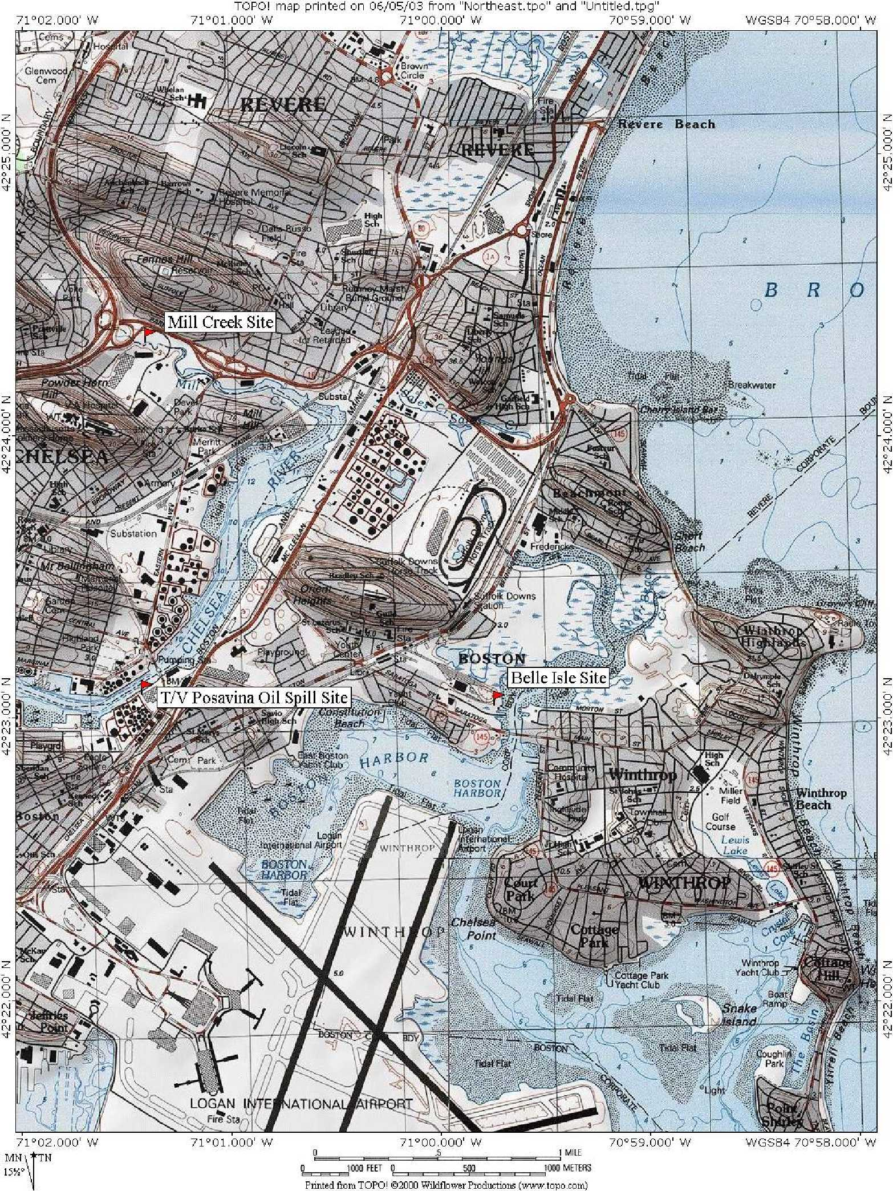

Figure 3
Design Plan for Mill Creek Salt Marsh Restoration
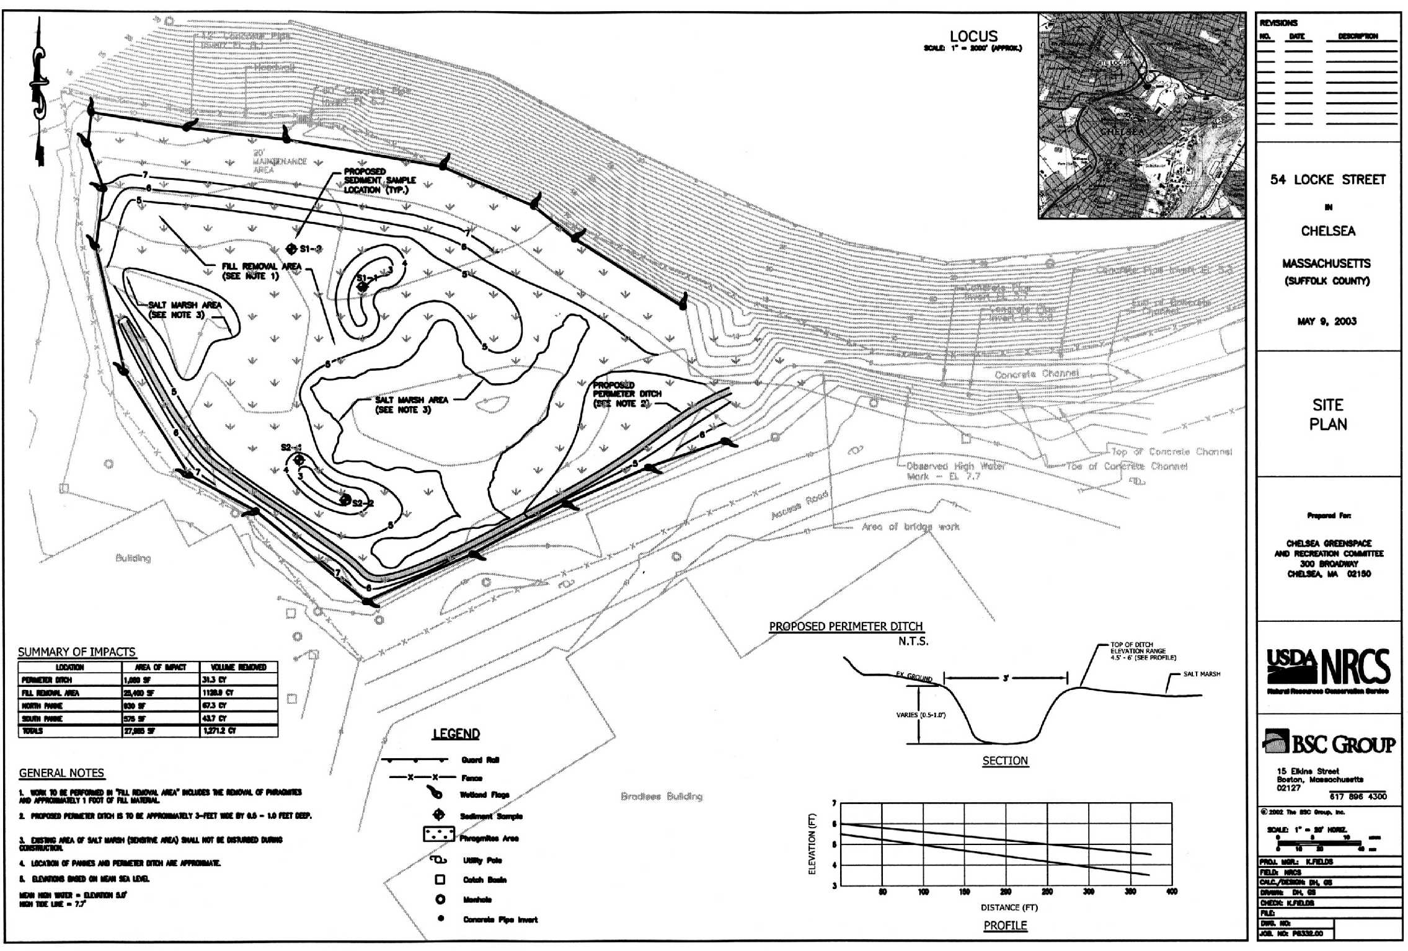
The Trustees believe that their proposed participation in and funding of this project will have substantive beneficial effects to restoring the natural resources that were injured as a result of the oil spill and monitoring the success of this project.
Restoration Objectives
This project is intended to provide compensatory restoration for the marine resources that were exposed to and/or injured by the T/V Posavina oil spill by increasing the aquatic functions and values of this one acre marsh. The marsh grade is currently elevated due to historic fill and stormwater sediments and provides minimal habitat for marine organisms because the marsh is seldom inundated with tide water. This proposed project seeks to lower the marsh elevations to enable natural resources to more functionally use this marsh.
Probability of Success and Monitoring
Restoring a marsh using the technologies and design contemplated here is an established process. The Trustees believe therefore that this project will achieve a high likelihood of success. Some of the settlement funds ($5,000.00) will be used to monitor this project for a two-year period to ensure there is, for example, beneficial vegetation propagation and invasive species control, appropriate hydrology, and an evaluation of other monitoring markers that will be established for this site. A monitoring plan will be prepared and available through the sponsors and the Administrative Record for this settlement.
Environmental and Socio-Economic Impacts
No long-term adverse environmental or socio-economic impacts are expected from this project. It is expected that the restored marsh will provide habitat for wading and shore birds which will in turn provide beneficial wildlife opportunities to local residents, a benefit that has not been available to them for over a decade. Minor short-term increases in turbidity are expected to occur during the physical excavation work. Turbidity impacts will be minimized by conducting marsh work during periods of low tide in accordance with all permit terms and conditions.
Cost
The Trustees propose to assist in implementing this project by providing $40,000.00 from the settlement with the Responsible Party. The estimated costs to fund this project through construction and provide two years of enhanced monitoring is $50,000.00. The COSRC has raised funds and in-kind support to design and construct this project including $10,000.00 from NOAA-NMFS Community-based Restoration Program. However these funds are not sufficient to complete this project and the additional $40,000.00 from the T/V Posavina settlement, along with in-kind services from its cosponsors, will enable implementation of this project. The COSRC will assume responsibility for final design, permitting and implementation of the project and for the evaluation of the success of the project. This broad partnership of federal, state and public groups will ensure a timely, cost-effective and accurate implementation of this project.
Evaluation
The Mill Creek restoration site was not directly impacted by the T/V Posavina oil spill, but is contiguous to the impacted area and will provide spawning, foraging and refugia habitat for common salt marsh animals found throughout the Chelsea River/ Mill Creek system. The final design of the project is being developed to prevent the future input of stormwater road sediments across the marsh surface. The developing project plan will also include a long term operations and maintenance plan from the Massachusetts Highway Department to maintain the on-site stormwater retention basin.
Although there will be some negative short-term impacts to natural resources as a result of the construction activities, the Trustees have determined that the project’s overall environmental impacts are positive. The permitting terms and conditions and other best management practices will ensure that there are minimal disturbances to the existing resources during project construction. The creation of a functioning salt marsh habitat will have long-term benefits for a number of fish and wildlife species and the marine community that were injured by the oil spill.
  - Evaluation of Restoration Alternative 3 (Preferred)
    - Belle Isle Fish Company Salt Marsh Restoration Project
Project Description
The project site consists of approximately 1.6 acres off Saratoga Street in East Boston (figures 3 & 4). The property, which was formally owned by the Belle Isle Fish Company, was a functioning salt marsh that has undergone historic filling with demolition materials such as concrete, wood, brick, and other debris. The impetus behind this project was the identification of contaminated upland sediments on-site that require remediation by the City of Boston under the Massachusetts Oil and Hazardous Material Release Prevention and Response Act (M.G.L Chapter 21E). Remediation will consist of removal and proper disposal of the contaminated material. Total cost of the remediation is expected to be upwards of $500,000.00. The requirements of the contamination cleanup do not include aquatic habitat restoration, and the salt marsh restoration described in the Final DARP/EA is a proactive supplement above and beyond the required mitigation requirements. The proposed remedial phase of the project consists of selective excavation and removal of wetland fill material. The one-acre site will be properly graded and restored by back-filling with appropriate soils and planting with indigenous, herbaceous salt marsh plant species (e.g. Spartina sp.) to restore the salt marsh habitat. The required remediation in combination with the additional restoration will enhance the wetland and wildlife values of the site and create an aesthetically attractive attraction point for bird watching.
Figure 4
Design Plan for Belle Isle Fish Company Salt Marsh Restoration
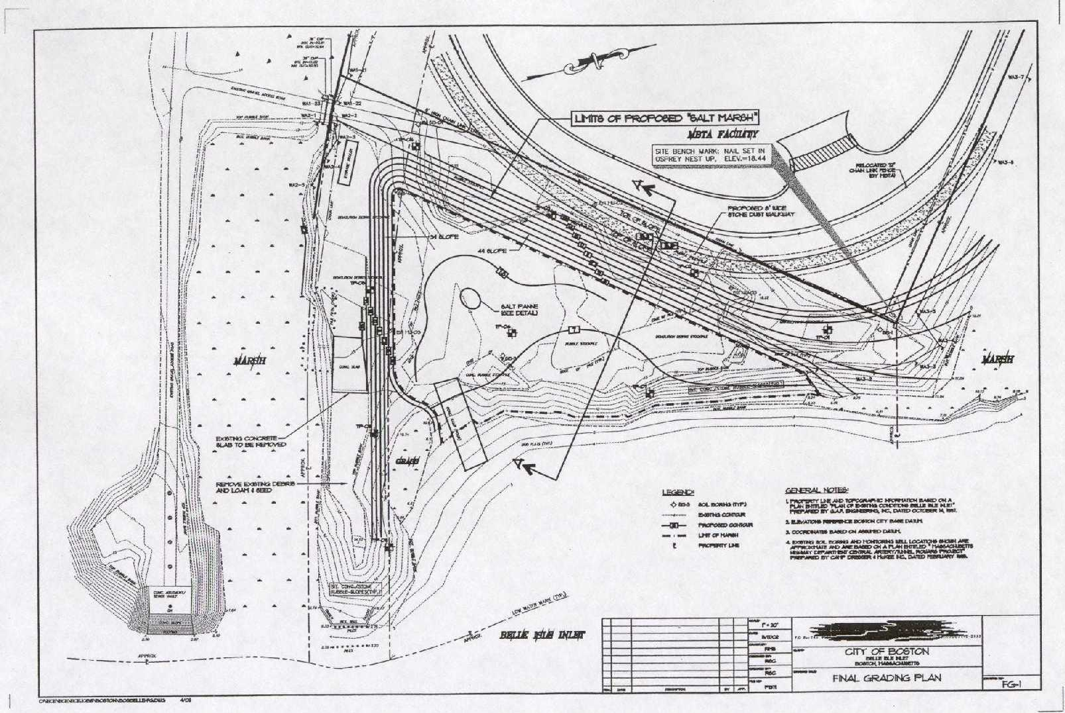
The project is being managed by the City of Boston Parks Department. The final permit plans have been submitted to local, state and federal regulatory agencies and the project is expected to be fully permitted during the summer of 2003. Construction bidding and notice to proceed could occur as early fall 2003. Opportunities for public comment are part of the permitting process and the City of Boston should be contacted for additional permitting information.
The Trustees believe that their proposed participation in and funding of this project will have substantial beneficial effects to restoring the natural resources that were injured as a result of the oil spill and monitoring the success of this project.
Restoration Objectives
This project is intended to provide compensatory restoration for the marine resources that were exposed to and/or injured by the T/V Posavina oil spill by restoring the aquatic functions and values of this one-acre marsh. The marsh grade is currently elevated due to historic fill and provides no habitat for marine organisms. The site was historically a salt marsh, which increases the probability that this restoration effort will succeed. The project is located within the state-designated Belle Isle Marsh Area of Critical Environmental Concern (301 CMR 12.00, 1993). The project site is located contiguous to a large area of healthy salt marsh and a medium depth tidal channel and is expected to quickly be colonized by source plants and animals from these adjacent habitats. Active planting of native salt marsh vegetation species will be conducted to stabilize and more rapidly restore functions and values.
Probability of Success and Monitoring
Restoring a marsh using the technologies and design contemplated here is an established process. The Trustees believe therefore that this project will achieve a high likelihood of success. Some of the settlement funds ($5,000.00) will be used to monitor this project for a two-year period to ensure that there is, for example, beneficial vegetation propagation and invasive species control, appropriate hydrology, and an evaluation of other monitoring markers that will be established for this site. The Trustees monitoring effort will be above and beyond the permitting requirements by the City of Boston. A monitoring plan will be prepared and available through the sponsors and the Administrative Record for this settlement.
Environmental and Socio-Economic Impacts
No long-term adverse environmental or socio-economic impacts are expected from the proactive restoration part of the overall BIFCO project. It is expected that the restored marsh will provide habitat for wading and shore birds which will provide beneficial wildlife opportunities to local residents, a benefit that has not been available to them for over a decade. Minor short-term increases in turbidity are expected to occur during the physical excavation work. Turbidity impacts will be minimized by conducting marsh work during periods of low tide and in accordance with all permit terms and conditions.
Cost
The Trustees propose to partially fund, in the amount of $60,000.00, only the restoration and monitoring phase of this project with monies partially provided from the settlement with the Responsible Party. The Trustees also propose to participate in the implementation of this project, along with in-kind services of the NOAA-NMFS Community-based Restoration program. Of this sum, the Trustees are recommending $55,00.00 to be expended on construction and $5,000.00 to be expended for 2 years of enhanced physical and biological monitoring. The estimated costs to fund the proactive phase of this project and provide two years of enhanced monitoring are difficult to exactly estimate because the project will be concurrently undertaken with the contamination remediation project. However, the best available information is that the proactive restoration component of this project will cost in the range of $100,000.00. The City of Boston will provide all remaining funds to implement this restoration project because of the difficulties associated with segregating the remedial action and the mitigation costs and the proposed supplemental restoration activities.
Evaluation
The Belle Isle Fish Company restoration site was not directly impacted by the T/V Posavina oil spill. However, the site is located in close proximity to the spill site, and is hydrologically connected by an underground culvert. The site is located within the larger Boston Harbor estuary and will provide spawning, foraging and refugia habitat for common salt marsh animals found throughout the estuary. The final design of the project is expected to be completed by July, 2003.
Although there will be some negative short-term impacts to natural resources as a result of the construction activities, the Trustees have determined that the project’s overall environmental impacts are positive. The permitting terms and conditions and other best management practices will ensure that there are minimal disturbances to the existing resources during project construction. The creation of a functioning salt marsh habitat will have long-term benefits for a number of fish and wildlife species and the marine community that were injured by the oil spill.
4.6 Non-Preferred Alternatives Discussion
The Trustees began identifying possible restoration sites simultaneously with the preassessment phase. The Trustees examined various options and sites, including potential opportunities associated with tidal restrictions, fill removal and sites where habitat restoration could result in enhanced functions and values to compensate for those lost from the T/V Posavina oil spill. However, most of the Chelsea Creek shoreline and the adjacent upland areas are privately owned and are being utilized for commercial marine industry. Most of the shoreline and historic wetland resources were filled or armored years ago and are not conducive to restoration due to technical, social and financial constraints. Additionally, the historical and current usage of these properties leads us to suspect that much of the shoreline property is contaminated and would make a small scale habitat restoration project very difficult to fund, permit and construct.
With the exception of the two restoration projects that the Trustees propose to partner with, as noted above, only three non-preferred restoration sites were identified due to the wide range of constraints in Chelsea Creek.
4.6.1 Condor Street
The first site, known at the Condor Street salt marsh restoration project, was initially targeted as a preferred alternative. The site is about eight acres, half of which are filled tidelands. The City of Boston owns the property, and under a remedial action chose to enhance their mitigation site by creating an urban green space along with a salt marsh fringe. The proactive restoration phase plan included removing deteriorated bulkheads and creating a salt marsh fringe along the intertidal area and enhancing public access to the site with a boardwalk.
At the time of the oil spill, no funding existed to ecologically restore the shoreline and salt marsh. The restoration was estimated to cost approximately $75,000 - $100,000. The project was considered “turn-key” because the City was already handling all engineering and permit requirements. While this site was originally targeted as potentially the preferred alternative, it was dropped from further consider in 2001 because the project became fully funded from other sources while the T/V Posavina settlement was underway. The project was completed in the fall of 2002, prior to the T/V Posavina settlement.
4.6.2 Parkway Plaza
The Parkway Plaza salt marsh restoration site, is located in the upper tidal section of Chelsea Creek. The privately owned filled wetland area is comprised of a steep eroding bank leading down to the Mill Creek salt marsh. However, the property has been identified as a Massachusetts General Laws Section 21E contaminated site and will require formal clean-up action by the current property owner prior to any potential on-site restoration. Future redevelopment of the site is being pursued by the current owner and it is unknown when the opportunity to work on the site would arise. This very small alternative site was eliminated due the above identified reasons.
4.6.3 Forbes Street Industrial Park
The Forbes Street Industrial Park is located one mile from the spill site consists of shoreline with severely eroding and non-habitable banks and deteriorated bulkheads. Many locations in this stretch of shoreline could be significantly improved by removing the bulkheads, peeling back a portion of the filled shoreline, creating salt marsh habitat and stabilizing the bank. This stretch of shoreline was significantly oiled by the spill. A number of variables eliminated this site from further consideration, including confusing land ownership, unknown but suspected contaminants on-site, and the Trustees’ belief that extensive shoreline restoration would be cost prohibitive.

4.7 Essential Fish Habitat Consultation
The Magnuson-Stevens Act (16 U.S.C 1801) as amended and reauthorized by the Sustainable Fisheries Act (Public Law 104-297) established a program to promote the protection of essential fish habitat (EFH) in the review of projects conducted under Federal permits, licenses, or other authorities that affect or have the potential to affect such habitat. After EFH has been described and identified in fishery management plans by the regional fishery management councils, Federal agencies are obligated to consult with the Secretary of Commerce with respect to any action authorized, funded, or undertaken, or proposed to be authorized, funded, or undertaken, by such agency that may adversely affect any EFH.
Both the Mill Creek and BIFCO projects will take place in waters discharging into the Chelsea River and Boston Harbor and are similar enough in location and scope to be simultaneously evaluated for affects to EFH. Species for which the Chelsea River and Boston Harbor has been designated EFH for one or more life stages and which may use the particular combination of salinity, temperature, bottom sediments and depth in close proximity to the restoration site includes the following species: Atlantic cod (Gadus morhua), Pollock (Pollachius virens), red hake (Urophycis tenuis), winter flounder (Pleuronectes americanus), yellowtail flounder (Pleuronectes ferruginea), windowpane flounder (Sclopthalmus aquosus), Atlantic sea herring (Clupea harengus), bluefish (Pomatomus saltrix), Atlantic butterfish (peprilus triacanthus), Atlantic mackerel (Scomber scombrus), and summer flounder (Paralichthys dentatus).
The Mill Creek and BIFCO marsh restoration projects described in Section 4.1 propose to enhance and restore salt marsh which habitat that is degraded from excessive stormwater runoff, historic filling and aggressively growing invasive plant species such as common reed (Phragmites australis). The specific details for both projects are just about complete and focus on fill removal and creating pannes and new tidal channels to increase tidal flow and depth at both locations. Both projects are expected to include planting of salt marsh vegetation (Spartina sp.) to encourage their growth and spread throughout the restoration sites. Resident salt marsh fish species will directly benefit from the additional tidal flow to areas of the marsh that are now only receiving infrequent storm tides as new foraging habitat will be opened up. Any turbidity plumes into the Chelsea River and Boston Harbor during construction are expected to be minor and short in duration. However, turbidity caused by such action should not be significantly different from ambient conditions with the implementation of appropriate Best Management Practices. For the foregoing reasons, the Mill Creek and BIFCO marsh restoration project are expected to result in only minor adverse affect to EFH of the species or life stages listed above and will be permitted with appropriate conservation recommendations.
The final design plans of both salt marsh restoration projects will require Section 404 (Clean Water Act) permitting from the Army Corps of Engineers. The Mill Creek site is expected to be permitted by the Army Corps through the Massachusetts General Programmatic Permit and the BIFCO site will be permitted through Army Corps Individual Permit review process due to the site remediation activities. Both projects will undergo final EFH review and sign-off at that time.

4.8 Threatened and Endangered Species Act Consultation
No Federally or State listed threatened or endangered species are known to permanently or seasonally inhabit either restoration site. The proposed actions would not have any adverse impact on endangered or threatened species. Completion of endangered and threatened species coordination with Federal and state programs will be coordinated as part of the Clean Water Act Section 404 regulatory process for implementing the preferred restoration alternatives.
4.9 Cumulative Effects of Preferred Alternatives
The two proposed restoration sites will restore approximately two acres of salt marsh habitat, which represents a relatively small area of the larger Chelsea Creek and Belle Isle Inlet estuaries. The Belle Isle Marsh area is composed of approximately 275 acres of salt marsh, salt meadow and tidal flats and the Chelsea Creek system is well over 3 miles long and also possess a few hundred acres of tidal flats, salt marsh and subtidal habitat. Although the two projects will provide site specific enhanced aquatic functions and values, effects to the larger estuaries and surrounding uplands would be quite minor and difficult to quantify.
Both Chelsea Creek and Belle Isle Inlet were impacted throughout the industrial era (between late 1800’s through the 1960’s) with channel deepening, marine transportation facilities, dense upland development and impervious surfaces. Future industrial impacts in the reasonably foreseeable future are expected to be quite minimal due to existing state and federal regulatory and management programs, further insuring that restoration activities will survive and not be adversely impacted by development. The completion of the two identified salt marsh restoration projects is not expected to significantly effect (either positively or negatively) either the Chelsea or Belle Isle regions, but in conjunction with other salt marsh restoration projects and existing salt marshes, will over time benefit the natural resources of this area and those resources impacted by the oil spill.
4.10 Summary of Preferred Restoration Alternatives and Costs
The Trustees have selected compensatory restoration alternatives which they believe will enhance the natural recovery of resources injured by the T/V Posavina oil spill, and/or will provide additional resource services to compensate the public for interim losses pending natural recovery. The Trustees believe that the two preferred projects, the Mill Creek Salt Marsh Restoration Project and the BIFCO Salt Marsh Restoration Project, will adequately address the injuries and interim service losses resulting from the T/V Posavina oil spill. In addition to the costs of implementing the preferred restoration alternatives, the Trustees are also recovering the costs associated with two years of restoration monitoring. Table 2 presents the total estimate of all costs, including the estimated costs for implementing the preferred restoration alternatives and the Trustees’ cost for two years of post-construction monitoring.

Table 1

SUMMARY OF PREFERRED T/V Posavina OIL SPILL RESTORATION PROJECTS AND COSTS
Resource/Service | Preferred Restoration Project | Total Cost to RP
Marine Community and Wetlands | Mill Creek Salt Marsh Restoration | $35,000
Marine Community and Wetlands | Belle Isle Fish Co. Salt Marsh Restoration | $55,000
Total Estimated Cost of Restoration Projects $90,000
Total Estimated Post-Restoration Monitoring $ 10,000
Total Restoration and Oversight Costs Payment by RP to Trustees $100,000

- PREPARERS, AGENCIES, AND PERSONS CONSULTED
5.1 Agencies and Persons Consulted

Federal Agencies
U.S. Army Corps of Engineers, Concord, MA
U.S. Fish and Wildlife Service, Concord, NH
National Marine Fisheries Service, Gloucester, MA
U.S. Environmental Protection Agency, Boston, Ma
Natural Resource Conservation Service, Hadley, MA

State Agencies
Executive Office of Environmental Affairs
Massachusetts Department of Environmental Protection
Massachusetts Department of Environmental Management
Massachusetts Office of Coastal Zone Management
State Historic Preservation Office
Massachusetts Wetlands Restoration Program

Local Agencies
Chelsea Conservation Commission
Chelsea City Council
Chelsea Housing Authority
Boston Conservation Commission
Boston Department of Parks and Recreation
Boston City Council

6.0 COMPLIANCE TABLE

6.1 Compliance with Environmental Federal Statues

Federal Statutes

- Preservation of Historic and Archeological Data Act of 1974, as amended, 16 USC 469 et seq.

Compliance: Project will be coordinated with the State Historic Preservation Officer. Consultation will be incorporated into the Section 404 and 401 permitting process.

- Clean Air Act, as amended, 42 USC 7401 et seq.

Compliance: Public notice of the availability of this report to the US Environmental Protection Agency is required for compliance pursuant to Sections 176C and 309 of the Clean Air Act. Consultation will be incorporated into the Section 404 and 401 permitting process.

- Clean Water Act of 1977 (Federal Water Polllution Control Act Amendments of 1970 33 U.S.C. 1251 et seq.

Compliance: A Section 404(b)(1) Evaluation and Compliance Review will be undertaken by the US Army Corps of Engineers. An application shall be filed for State Water Quality Certification pursuant to Section 401 of the Clean Water Act.

- Coastal Zone Management Act of 1982, as amended, 16 U.S.C. 1451 et seq.

Compliance: A CZM consistency determination shall be provided to the State for review and concurrence that the proposed project is consistent with the approved State CZM program. CZMA consistency determination is incorporated into the Clean Water Act Section 404 and 401 permitting process noted above.

- Endangered Species Act of 1973, as amended, 16 U.S.C. 1531 et seq.

Compliance: Coordination with the U.S. Fish and Wildlife Service (FWS) and the National Marine Fisheries Service (NMFS) will be completed pursuant to Section 7 of the Endangered Species Act. Consultation is incorporated into the Sec. 404 and 401 permitting process noted above.

- Fish and Wildlife Coordination Act, as amended, 16 U.S.C. 661 et seq.

Compliance: Coordination with the FWS, NMFS, and the State fish and wildlife agencies signifies compliance with the Fish and Wildlife Coordination Act.

- National Historic Preservation Act of 1966, as amended, 16 U.S.C. 470 et seq.

Compliance: Coordination with the State Historic Preservation Office will be completed and signify compliance. Consultation is incorporated into Sec. 404 and 401 permitting process noted above.

- National Environmental Policy Act of 1969, as amended, 42 U.S.C. 4321 et seq.
Compliance: Preparation of an Environmental Assessment signifies partial compliance with NEPA. Full compliance shall be noted at the time of Finding of No Significant Impact or Record of Decision is issued. The Trustees have integrated this Restoration Plan with the NEPA process to comply, in part, with those requirements. This integrated process allows the Trustees to meet the public involvement requirements of OPA and NEPA concurrently. The Final RP/EA will accomplish compliance by summarizing the current environmental setting, describing the purpose and need for the restoration actions, identifying alternative actions, assessing the preferred actions’ environmental consequences, and summarizing opportunities for public participation in the decision process.

Project-specific NEPA documents will be prepared as part of the Section 404 permitting process.

- Rivers and Harbors Act of 1899, as amended, 33 U.S.C. 401 et seq.

Compliance: The project will simultaneously apply for and receive Clean Water Act (Section 404) and Rivers and Harbors Act of 1899 during the permitting process. Consultation is incorporated into the Sec. 404 and 401 permitting process.

- Watershed Protection and Flood Prevention Act as amended, 16 U.S.C. 1001 et seq.

Compliance: Floodplain impacts will be considered prior to selection of final projects plans.

- Magnuson-Stevens Act Fishery Conservation and Management Act, as amended, 16 U.S.C. 1801 et seq.

Compliance: Coordination with the National Marine Fisheries Service and preparation of an Essential Fish Habitat (EFH) Assessment signifies compliance with the EFH provisions of the Magnuson-Stevens Act. Consultation is incorporated into Sec. 404 and 401 permitting process.

- Information Quality Guidelines issued Pursuant to Public Law 106-554.

Compliance: As the lead natural resources trustee, NOAA developed and confirms that this information product meets its Information Quality Act guidelines, which are consistent with those of the U.S. Department of the Interior and the Office of Management and Budget.

- Marine Mammal Protection Act, 16 U.S.C. 1361-1326, 1371-1384 note, 1386-1389, 1401-1407, 1411-1418, 1421-1421h.

Compliance: Activities associated with these projects will not have an adverse effect on marine mammals. Consultation is incorporated into Sec. 404 and 401 permitting process.

- Oil Pollution Act of 1990 (OPA), 33 U.S.C. 2701-2706, et. Seq., 15 C.F.R. Part 990

Compliance: OPA establishes a liability regime for oil spills that injure or are likely to injure natural resources and/or the services that those resources provide to the ecosystem or humans. OPA provides a framework for conducting sound natural resource damage assessments that achieve restoration. The process emphasizes both public involvement and participation by the Responsible Parties. The Trustees have conducted this assessment in accordance with OPA regulations.

- Migratory Bird Treaty Act, 16 U.S.C. 703-712 et seq.

Compliance: The Migratory Bird Treaty Act affirms and implements four bilateral international conventions with Canada, Mexico, Japan, and Russia explicitly for the protection of bird resources shared between the United States and the four treaty partners. Under the Act, it is unlawful for a person to take (i.e. kill, capture, wound, trap, etc.), import, export, possess, buy, sell, purchase, or barter for any migratory bird or its feathers, parts, nests, and eggs or any product made from migratory birds, unless a permit is obtained for such actions. Activities associated with this project will not require obtaining a Migratory Bird Treaty Act permit.

Executive Orders

- Executive Order 11593, Protection and Enhancement of the Cultural Environment, 13 May 1971

Compliance: Coordination with the State Historic Officer will signify compliance. Consultation is incorporated into the Sec. 404 and 401 permitting process.

- Executive Order 11990, Protection of Wetlands, 24 May 1977.

Compliance: Public notice of the availability of this report for public review fulfills the requirements of Executive Order 11990, Section 2 (b). Consultation is incorporated into Sec. 404 and 401 permitting process.

- Executive Order 11988, Floodplain Management, 24 May 1977 amended by
Executive Order 12148, 20 July 1979.

Compliance: Public notice of the availability of this report or public review fulfills the requirements of Executive Order 11988, Section 2(a) (2). Consultation is incorporated into the Sec. 404 and 401 permitting process.

- Executive Order 12898, Environmental Justice, 11 February 1994.

Compliance: Not applicable, the project is not expected to have a significant impact on minority or low income population, or any other population in the United States.

- Executive Order 13007, Accommodation of Sacred Sites, 24 May 1996

Compliance: Not applicable unless on Federal lands, then agencies must accommodate access to and ceremonial use of Indian sacred sites by Indian religious practitioners, and avoid adversely affecting the physical integrity of such sacred sites.

- Executive Order 13045, Protection of Children from Environmental Health Risks and Safety Risks. 21 April, 1997.

Compliance: Not applicable, the project would not create a disproportionate environmental health or safety risk for children.

Executive Memorandum

- Analysis of Impacts on Prime or Unique Agricultural Lands in Implementing NEPA, 11 August, 1980.

Compliance: Not applicable if the project does not involve or impact agricultural lands.

7.0 REFERENCES

- General Laws of Massachusetts, Chapter 21E, Massachusetts Oil and Hazardous Material Release and Prevention Act.
- SCAT Report, T/V Posavina Shoreline Cleanup Assessment Team (SCAT) Shoreline Cleanup Recommendations and Segment Signoffs, July 12, 2000.
- General Laws of Massachusetts, Chapter 301CMR 12.00, 1993 Areas of Critical Environmental Concern.

8.0 ADMINISTRATIVE RECORD

- SCAT Report, T/V Posavina Shoreline Cleanup Assessment Team (SCAT) Shoreline
Cleanup Recommendations and Segment Signoffs, July 12, 2000.
- Environmental Notification Form, Massachusetts Environmental Policy Act, 301 Code of Massachusetts Regulations 11.00, Remediation and Salt Marsh Restoration at Belle Isle Inlet, April 24, 2002.
- Draft Site Plan, 54 Locke Street (Mill Creek Restoration Project), Prepared by USDA/NRCS and the BSC Group, May 9, 2003.
- Five-Star Restoration Challenge Grant Proposal, Mill Creek Restoration 2000, March
2, 2001.

APPENDIX A. FINDING OF NO SIGNFICANT IMPACT (FONSI)

Final
Damage Assessment and Restoration Plan/Environmental Assessment
For the T/V Posavina Oil Spill
Chelsea River, Chelsea and Boston, Massachusetts

The National Oceanic and Atmospheric Administration (NOAA) is the lead Federal agency for the National Environmental Policy (NEPA) compliance for the Final Damage Assessment and Restoration Plan Environmental Assessment (DARP/EA) to restore natural resources injured by the June 8, 2000, vessel collision and oil spill in the Boston and Chelsea, Massachusetts. This plan was developed in cooperation with the Massachusetts Executive Office of Environmental Affairs and the U.S. Department of the Interior (U.S. Fish and Wildlife Service) as cooperating trustees.

A draft of this document was available for public review and comment for 30 days starting September 2, 2003. A notice announcing the availability of the Draft DARP/EA and the period for public review was published in the Boston Globe. This notice also invited the public to propose other restoration alternatives and to comment on the alternatives proposed by the Trustees. All comments received were considered by the Trustees before finalizing this DARP/EA.

This Final DARP/EA presents two project proposals: salt marsh restoration at Mill Creek ($40,000.00), and salt marsh restoration at Belle Isle Inlet ($60,000.00).

To comply with the requirements of NEPA, the Trustees analyzed the effects of the alternatives proposed by the Trustees on the quality of the human environment. NEPA’s implementing regulations direct federal agencies to evaluate the potential significance of proposed actions by considering both context and intensity. For the actions proposed in this Final DARP/EA, the appropriate context for considering potential significance of the action is local, as opposed to national or worldwide. With respect to evaluating the intensity of the impacts of the proposed action, NEPA regulations (40 C.F.R. § 15-8/27) suggest consideration of ten factors. These are addressed in the Final DARP/EA and summarized below.

- Likely impacts of the proposed projects:
Both projects address the injury of biological loss of salt marsh, unconsolidated sediment substrate and algae covered hard substrates found in the Chelsea River. The Mill Creek project will enhance the functions and values of a salt marsh by removing accumulated stormwater sediments on the marsh surface and the direct removal of invasive vegetation. The Belle Isle project will result in the restoration of area of salt marsh that was filled with construction debris. Once salt marshes are filled or clogged with stormwater sediments they loose much of their important functions they perform, such as providing fish and bird habitat. The direct, long-term ecological impacts of both projects are beneficial in that each promotes formation of functioning salt marsh habitat. Because the land adjacent to both will have some level of public access, the projects will also result in enhanced human values associated with bird watching.

Neither of these projects is expected to require substantial long-term maintenance.

Short-term impacts include noise and exhaust from use of heavy equipment used for cutting invasive plants and hauling sediments from the salt marsh. Work at both sites will be done during the day only, and will be scheduled to avoid spring high tides to minimize turbidity in adjacent waters. Work on these projects may result in minimal and short duration disturbances, if any, to both humans and wildlife in the project area.

- Likely effects of the project on public health and safety:
There are no foreseeable effects on human health and safety other than possible accidents related to heavy machinery operation.

- Unique characteristics of the geographic area in which the projects are to be
implemented:
The areas in which these projects will take place present no unique characteristics that make distinct from the other local areas of salt marsh.

- The degree to which the effects on the quality of the human environment are likely to
be highly controversial:
Both projects have been available for public review and generated only minor
response. Neither is likely to be highly controversial.

- Degree to which possible effect of implementing the project are highly uncertain or
involve unknown risks:
Both types of projects have been done elsewhere so no great uncertainties or risks are expected.

- Precedential effect of the project on future actions that may significantly
affect the human environment:
Since both types of projects have already been done elsewhere, there is no precedential effect.

- Possible significance of cumulative impacts from implementing this and other similar projects:
Both projects are quite small in scale and effects are very localized, so cumulative impacts are not significant.

- Effects of the projects on Historic Places, or likely impacts to significant cultural, scientific, or historic resources:
Both projects are being coordinated with the State Historic Preservation Officer and with federal and state agencies responsible for natural resources to ensure there are no likely impacts to significant cultural, scientific, or historic resources.

- Degree to which the project may adversely affect endangered or threatened species or their critical habitat:
Both projects are being coordinated with federal and state agencies responsible for natural resources to ensure that there are no likely impacts to endangered or threatened species or their critical habitat.

- Likely violations of environmental protection laws:
Both projects have been planned to be in compliance with all applicable environmental protection laws, and no violations are likely or expected. In addition, both projects will be implemented in compliance with all permits required by the state and federal regulatory agencies.

In each project, the effects were judged to be beneficial though not significant as defined by NEPA.

Both projects will be implemented in compliance with all permits by the state and federal regulatory agencies.

DETERMINATION:

Based upon an environmental review and evaluation of the Final Damage Assessment and Restoration Plan/Environmental Assessment (DARP/EA) to restore natural resources injured by the June 8, 2000, vessel collision and oil spill in Boston and Chelsea, Massachusetts, I have determined that the proposed action does not constitute a major federal action significantly affecting the quality of the human environment within the meaning of Section 102(2)(c) of the National Environmental Policy Act of 1969, as amended. Accordingly, an environmental impact statement is not required for these projects.

_____________________________________________ _______________
William T. Hogarth, Ph.D. Date
Assistant Administrator for Fisheries
National Marine Fisheries Service
National Oceanic and Atmospheric Administration

